1.Load the file “zoo.data” and look at the info and first five rows. The first column denotes the animal name and the last one specifies a high-level class for the corresponding animal.

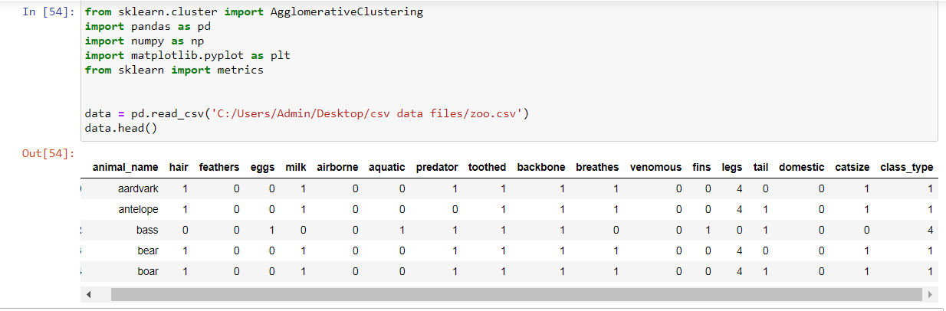

2. Find out the unique number of high level class.

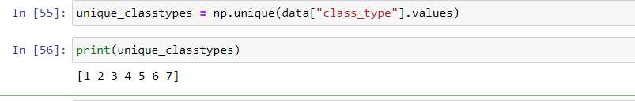

3. Use the 16-intermediate feature and perform an agglomerative clustering.

[ Hint: Refer to the agglomerative clustering module in scikit learn and set the number of clusters appropriately]

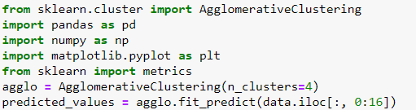

4.Compute the mean squared error by comparing the actual class and predicted high level class

